**P1 – Explain the types of control systems**

**Introduction**

In this assignment, I will be explaining firstly what control system is. They are different types of control systems and I am going to be explaining the following types:

* Command systems
* Programmable systems
* Sensing systems
* Conditional systems

**What is a control system?**

A control system is a device, or many devices put together, or a system of hardware that manages, gives instructions to another device, commands that controls a hardware. They are many examples e.g. robots, lifts, traffic lights, automatic doors and many more. They are many control systems that we use daily. They are many types of control systems but they all control something. As said before, they are many devices that are used daily by people. They will not even realise that they are using a control system.

**The command system**

The command system is the simplest out of them all. As the name suggest, this system gives only commands to the device the system is trying to control. An easy example could be a TV remote. This system works by the user giving a command. This command could be by pressing the on button. Then, the command is sent to the TV and it works. This is very simple and easy. All of the system have a ‘command’ within them, but this the simplest. Another ‘command system’ example could be a PS3/PS4 controller. These are only have one command system. For example, once the ‘X’ button has been pressed, it selects something to do on the PS3/PS4.



**The programmable systems**

The programmable systems is a control system that has a number of options to do something. Unlike the command system, it has a range of options to do something and this is much more complex. Any example could be the following:

* Washing Machine
* Microwave

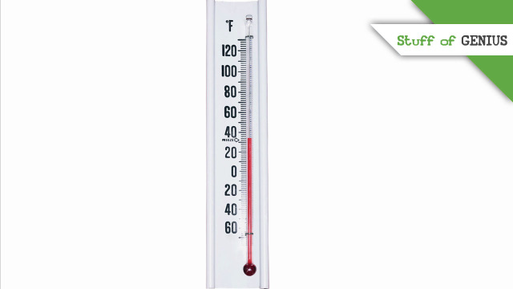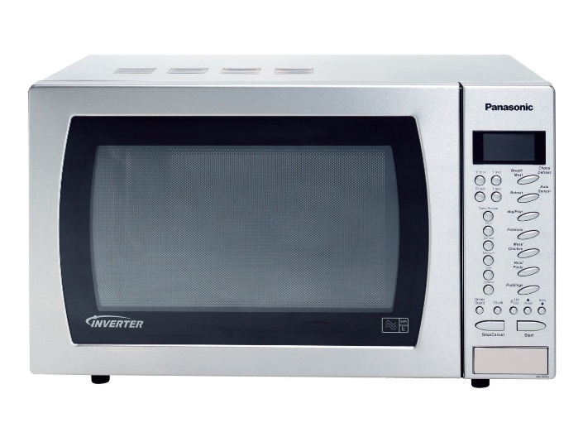These are programmable systems because they offer more than one option. For example, for microwave, the user can change how long he wants to heat his food. Washing machine is different but the same. It offers which way you want to wash your clothes and the time of it. Also, depending on the type of material, the programs are changed occurring to the material of the clothes. It is similar and offers more than one option unlike command system.

**The sensing systems**

The sensing system, as the others, it is a control system uses an electronic device to see some aspect of the environment. An example of this type of system could be a thermometer. This is an example as it detects the temperature of the environment and it tells on the thermometer whether it is hot or not e.g. in Africa, it will be hot. Another example could be turning the boiler on and off. This is a sensing system, the name gives it away, ‘sensing’ it is there to ‘sense’ something. Apart from the thermometer, they are more examples such as;

* Automatic doors
* Temperature (on and off one)

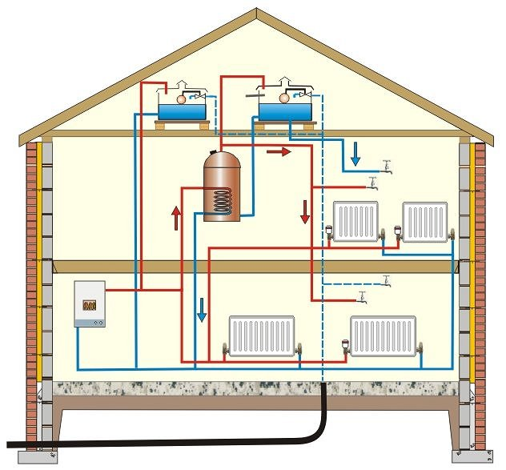**The conditional systems**

The conditional systems is very much like the previous one that I have named. It involves the same similarities with the central heating and thermometer. They are some of the central parts where conditional systems that they control. However, the other systems control some part of it which is why I have named it in that system. Therefore, the three systems that are controlled is conditional and sensing systems. An example of what the conditional system can do is that it can turn on or off depending on the temperature.